Weekly Construction Progress Report – Week 31
Harrow Bay Offshore Wind · 27 Jul – 02 Aug 2026
Elena Márquez · 03 August 2026 · HB-PM-RPT-2026-W31

1. Summary
No piling this week (seasonal piling restriction). The total remains 10 of 40 monopiles. The foundation campaign is 2 piles behind the Rev 2 baseline (12 planned). Waiting on weather amounted to 7 hours.
Area | Status | Comment
Overall schedule | Amber | 10/40 monopiles vs. 12 planned
Foundations | Amber | TPs installed: 10
Offshore substation | Green | Jacket installed 27 Jun
Cables | Red | Export cable 2 delay – HB-RISK-017
HSE | Green | No incidents

2. Progress
Metric | This week | Cumulative | Plan (cum.) | Variance
Monopiles installed | 0 | 10 | 12 | -2
Transition pieces installed | 0 | 10 | – | –
Waiting on weather (h) | 7 | 220 | – | –
Persons on board (avg.) | 101 | – | – | –
Man-hours MV Sea Atlas | 8,670 | 136,201 | – | –
Lost time injuries | 0 | 0 | 0 | 0
Recordable injuries | 0 | 1 | – | –
Near misses reported | 0 | 3 | – | –
HSE observation cards | 31 | – | – | –

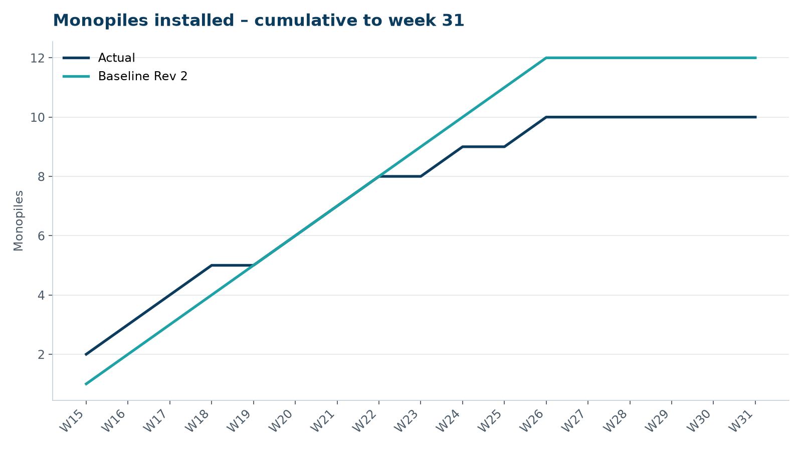
Figure 1 – Monopile installation progress, W15 to W31

3. Key activities this week
- Severn Subsea Cables confirmed that a 9 km section of export cable 2 will be re-manufactured; indicative delay of 8 weeks to delivery.
- MV Sea Atlas loaded out monopiles HB-A11 to HB-A13 and remobilised on 31 July.
- Seasonal piling restriction ended on 31 July.

4. Health and safety
No lost time injuries. 31 observation cards submitted; top theme: hand protection.

5. Environment
- No piling this week; passive acoustic monitoring stations HB-PAM-01 to -04 operational.

6. Issues and risks
- HB-RISK-017 export cable 2 delay – re-manufacture of 9 km section confirmed; delivery forecast 12 March 2027.
- HB-RISK-001 weather: 7 h downtime this week.

7. Look-ahead next week
Install HB-A11 and HB-A12; prepare OSS topside lift.
Prepared by Project Controls (Gareth Lewis); approved by Elena Márquez. Distribution: project team, Steering Committee, Halden Turbine Systems, Lenders' Technical Adviser.

